

भारतीय विमानपƣन Ĥाधिकरण

**AIRPORTS** **AUTHORITY** **OF** **INDIA**

**(A** **Category** **– 1 ‘Mini Ratna’ Public Sector Enterprise)**

**Eastern** **Region,** **NSCBI** **Airport,** **Kolkata-52**

**ADVT.** **NO.** **05/2025/APPRENTICE/GRADUATE/DIPLOMA/ITI/ER**

## Notification for Engagement of Graduate/Diploma/ITI Apprentices (under Apprentices Act, 1961) for year 2025-26 in Airports Authority of India, Eastern Region

Airports Authority of India (AAI) (Schedule – ‘A’ Miniratna Category-1 Public Sector Enterprise) was constituted by an Act of Parliament and came into being on 1st April, 1995 by merging erstwhile National Airports Authority and International Airports Authority of India. The merger brought into existence a single organization entrusted with the responsibility of creating, upgrading, maintaining and managing civil aviation infrastructure both on the ground and air space in the country.

Airports Authority of India, Regional Headquarter (Eastern Region) is inviting applications for Apprenticeship Training Program in RHQ and various airports in Eastern Region for the year 2025-26. During the period of Apprenticeship, the candidates are governed by Apprentices Act 1961 (as amended in 1973 and till date) and commensurate policies/rules of the organization.

**A.** **Details** **of** **posts** **and** **qualifications** **(No.** **of** **posts** **are** **tentative** **that** **can** **be** **reduced/increased):**

|  |  |  |  |  |  |
| --- | --- | --- | --- | --- | --- |
| **Sl.** **No** | **Discipline** | **No.** **of** **Seats** | **Duration** **of** **Training** | **Monthly** **Stipend** | **Locations/** **Airports** **of** **Apprenticeship** **Training** **under**  **Eastern** **Region** |
| 1. | Graduate | 42 | 01  Year | 1.Rs. 15000/-  (Graduate Apprentices) | 1. RHQ (ER) 2. Berhampur |

|  |  |  |  |  |  |
| --- | --- | --- | --- | --- | --- |
| 2. | Diploma | 47 | 01  Year | 2.Rs. 12000/-  (Diploma Apprentices) | 1. Bagdogra 2. Bhubaneswar 3. Cooch Behar 4. Deoghar 5. Gaya 6. Jharsuguda 7. Patna 8. Pakyong 9. Port Blair 10. Raipur 11. Ranchi 12. Darbhanga |
| 3. | ITI Trade (Computer Operator  & Programming Assistant, Electrical, Mechanic, Electronics) | 46 | 01  Year | Rs. 9000/- |

**Last** **date** **of** **application:** **31/05/2025** *(please* *read* *the* *general* *instructions* *carefully* *before* *applying)*

**PERIOD** **OF** **APPRENTICESHIP** **TRAINING**: Period of Apprenticeship Training shall be 12 months from commencing of the Contract of Apprenticeship.

**B.** **EDUCATIONAL** **QUALIFICATION:**

1. **Graduate** **&** **Diploma:** Candidates should possess full time (regular) four years degree or three years (regular) diploma in Engineering in any of the above- mentioned streams, recognized by AICTE, GOI.
2. **ITI** **Trade**: Candidates should possess ITI/NCVT certificate of the above-mentioned trades from institutes recognized by AICTE, GOI.

**C.** **CONDITIONS:**

* 1. Apprentices shall have to undergo Apprenticeship training at notified Airports/Establishments. **The** **allocated** **airport/station/unit** **will** **be** **final;** **no** **change** **in** **place** **of** **training** **will** **be** **done.**
  2. As per the provisions of the Apprentices Act, 1961 as amended from time to time, candidates who have already completed their apprenticeship or terminated their apprenticeship midway or are pursuing in other organizations or in AAI with the

same qualification level, shall not be eligible for engagement as apprentice.

* 1. As per the Apprentices Act, 1961, candidates who had apprenticeship training/job experience for a period of 1 year or more after the attainment of essential qualifications, shall not be eligible for engagement as apprentice.

**D.** **ELIGIBILITY** **CRITERIA:**

1. Only Indian Nationals **under** **the** **Eastern** **Region** **(candidates** **of** **West** **Bengal,** **Odisha,** **Bihar,** **Jharkhand,** **Chhattisgarh,** **Sikkim** **and** **Andaman** **Nicobar)** are eligible to apply under this advertisement.
2. Candidates passed degree/diploma **in** **2023** **or** **after** **2023** are eligible.
3. Age limit: Maximum Age is 26 years as on **31** **/** **03** **/2025**. ((Relaxation in upper age limit for categories like SC/ST/OBC/PWBD etc. as per Govt. of India guidelines is applicable)

**APPLICATION/** **REGISTRATION** **PROCESS**

* 1. The interested candidates are required to apply through BOAT/RDAT’s web portal [**https://nats.education.gov.in**](https://nats.education.gov.in/) (graduate/diploma apprentices) and **https://**[**www.apprenticeshipindia.gov.in**](http://www.apprenticeshipindia.gov.in/) (for ITI Trade) by finding establishment **Airports** **Authority** **of** **India** **–RHQ** **ER,** **Kolkata** (EWBPNC000015) and click the apply button in the next page. After successful application, the message “Successfully applied for the training position. Based on availability, you will be contacted by the establishment” will appear.
  2. **Candidates** **should** **register** **themselves** **with** **the** **concerned** **portal** **(NATS/NAPS/RDAT)** **prior** **to** **applying** **for** **apprenticeship** **training** **in** **AAI** **without** **fail.** Correspondence/Communication in any other manner will not be entertained.
  3. No TA/DA will be provided.
  4. The number of candidates to be engaged is indicative and may undergo changes without any further notification.
  5. During the period of apprenticeship, candidates will be governed by the

Apprentices Act, 1961 (as amended in 1973 and till date) and the policies/rules of the organization.

**MODE** **OF** **SELECTION**

1. The provisional selection of the candidate shall be made based on the percentage of marks obtained in the qualifying examination. Date of birth and there after date of passing will be taken as seniority in case of equal percentage of marks of the candidates.
2. CGPA shall be converted into percentage as per the norms of the concerned Educational Board/University.
3. The eligible candidate shall be called for document verification at establishment office through registered email -ids only.
4. The date, time and venue for document verification shall be intimated to the eligible candidates accordingly.
5. The candidates would be required to furnish original documents and submit self-attested copies and soft copies thereof.
6. Final selection of the candidates in each seat shall be made after verification of documents and found fit in medical examination. Shortlisted candidates merely attending the document verification process or medical examination does not entitle selection of his candidature as Apprentice with establishment.
7. After document verification and obtaining medical fitness certificate the candidates shall be selected for training, based on merit and apprentice engagement letter shall be issued.
8. Selected candidates will be posted preferably at the given locations in Eastern Region based on their registration location (in portal).

**REGISTRATION** **OF** **CONTRACT**

The Selected apprentice will have to sign and accept contract of apprenticeship training at the NATS portal of the Board of Apprenticeship Training immediate after joining at Airports Authority of India.

**TERMINATION** **OF** **CONTRACT**

After completion of such apprenticeship Training for stipulated period of 12 months, the Apprenticeship Contract shall automatically cease. Any act of indiscipline on the part of the apprentices during the apprenticeship is subject to cancellation Contract thereby discontinuing

of training

**OBLIGATIONS** **OF** **APPRENTICES**

Every Graduate and Technician apprentice undergoing apprenticeship training shall have the following obligations, namely: a) to learn his subject field in engineering or non-engineering or technology conscientiously and diligently at his place of training. b) to attend the practical and instructional classes regularly. c) to carry out all lawful orders of his employer and superiors in the establishment. d) to maintain a Work Dairy in specified format given below and countersigned by his supervisor once a week

**ASSESSMENT** **OF** **APPRENTICES**

Apprentices undergoing apprenticeship training, will be assessed every quarter and will undergo skill assessment test (online) after the completion of apprenticeship. Certificates to apprentices shall be awarded only upon completion of all assessments.

**RESERVATION**

1. Reservation will be provided as per the provisions of the Apprentice Act, 1961(amended) and Apprenticeship Rules 1992 (amended).
2. Applicants belonging to reserve categories shall produce their valid caste certificate in the prescribed format as stipulated by the Central Government for SC/ST/OBC category candidates issued by the Competent Authority applicable for jobs, valid on the date of verification. In case of candidate belongs to Non-Creamy Layer of OBC category, certificate should be specifically containing a clause that "the candidate does not belong to Creamy Layer Section" and the same should be valid on the date of document verification.
3. When the prescribed number of persons belonging either to the Scheduled Castes or to the Scheduled Tribes are not available on the seniority list of the establishment, the training places so reserved for them shall be filled by persons belonging to the Scheduled Tribes or as the case may be, to the Scheduled Caste and if the prescribed training places cannot be filled even in the above given manner, then the training places so lying unfilled shall be filled by persons available on the establishment's down the merit list not belonging to the Scheduled Castes or the Scheduled Tribes.
4. The prescribed training places cannot be filled from OBC candidates, then the training places so lying unfilled shall be filled up by Candidates not belonging to the

OBC category, from down the merit list.

**GENERAL** **INSTRUCTIONS**

* 1. **Airports** **Authority** **of** **India** **has** **no** **obligation** **to** **give** **regular** **employment** **to** **Apprentices.** They shall have no right to claim regular employment from AAI on the basis of this apprenticeship at any point of time. This training program shall not create any liability on AAI for providing any job to the Apprentice. AAI management does not take any responsibility for any sort of employment/placement.
  2. The decision of Management will be final and binding on all candidates on all matters relating to eligibility, acceptance or rejection of the applications, mode of selection, cancellation of the selection process either in part or full, etc. No correspondence will be entertained in this regard. Filling up of the seats is solely at the discretion of the management based on suitability of candidates and no claim will entertained, if some of these seats are not filled due to unsuitability/insufficient number of candidates.
  3. AAI Management does not take any responsibility to reply to the candidate / organization for non-selection /non-issuance of call letter.
  4. Verification of credentials shall be done prior to final selection and in case any deviation or non-conformity with the desired eligibility criteria, the candidature of the candidate shall be summarily rejected.
  5. Candidates belonging to reserve categories shall produce valid caste certificate in the prescribed format as stipulated by the Central Government for SC/ST/OBC category candidates issued by the Competent Authority applicable for jobs, valid on the date of verification. In case of candidate belongs to Non Creamy Layer of OBC category, certificate should be specifically containing a clause that "the candidate does not belong to Creamy Layer Section" and the same should be valid on the date of document verification.
  6. Candidates shall have to produce their valid Aadhar Card as Identity Proof, Mark- sheet of qualifying Examination, Proof of date of birth, document as NATS enrolment proof, Caste Certificate and Non-Creamy Layer Certificate valid till date of verification, duly signed with photograph on-line web application form in original during the verification of documents.
  7. Date of Birth will be taken as mentioned in the Mark-sheet or Certificate of class Xth or XIIth (HSSC/SSC Board) or equivalent examination. No other proof for date of birth shall be accepted.
  8. It shall be the sole responsibility of the candidates to get their profile verified from the respective regional Board.
  9. Candidates applying for more than one discipline will not be considered and their application will be rejected.
  10. **No** **Application** **Fee** is being charged.
  11. No TA / DA will be paid to applicants called for document verification process and for any stage of engagement process as Apprentice.
  12. No accommodation, food etc will be provided at any stage.
  13. The candidature of the applicant would be provisional, subject to verification of all certificates and submission of certificate of Medical Fitness (to be obtained only from a Government Medical officer/Medical Officer of a Government Undertaking) at the time of joining.
  14. At any stage of selection process, if it is found that the candidate has furnished false or incorrect information, then the candidature/engagement of the candidate is liable to be cancelled.

## For BOAT/Portal- [www.nats.education.gov.in](http://www.nats.education.gov.in/) related queries please email or reach out to - Eastern Region Students, Email: [bopter@gmail.com,](mailto:bopter@gmail.com) [bopterosdit@gmail.com](mailto:bopterosdit@gmail.com) Phone- 0512 2584056/2584057/2580349. For any ITI trade related clarification/queries candidates may contact via e-mail [apprenticeship@nsdcindia.org](mailto:apprenticeship@nsdcindia.org) or log on to [www. apprenticeshipindia.org](http://www.apprenticeshipindia.org/)

* 1. In case of any dispute, **English** **version** of notice and communication will be treated as valid.

Hindi version followed.

# ANNEXURE-I

**PROCEDURE** **FOR** **ENROLLMENT** **IN** **NATS** **PORTAL**

A candidate should possess any of the following qualifications to enroll himself/herself as an apprentice:

* + 1. Graduation
    2. Diploma

## Checklist for Enrollment:

Candidates should have the following details ready to complete the enrollment process:

1. University Reg. No./Roll No./Enroll. No.
2. Final Degree/Diploma Certificate/Consolidated Mark sheet (Scanned copy for uploading: Format: PDF, Size: Less than 1MB)
3. Name of College/University
4. Percentage of marks or CGPA
5. Branch of study
6. Month and year of Passing
7. Aadhar Card Number
8. Bank details
9. Valid personal E-mail ID &Mobile No. (Will be required to send/verify OTP)
10. Passport size photograph (Scanned copy for uploading: Format: JPEG, Size: Less than 1MB)

## Steps for Enrollment:

1. Logon to website **portal-** **https://nats.education.gov.in** and Click on **“Enroll” tab**.

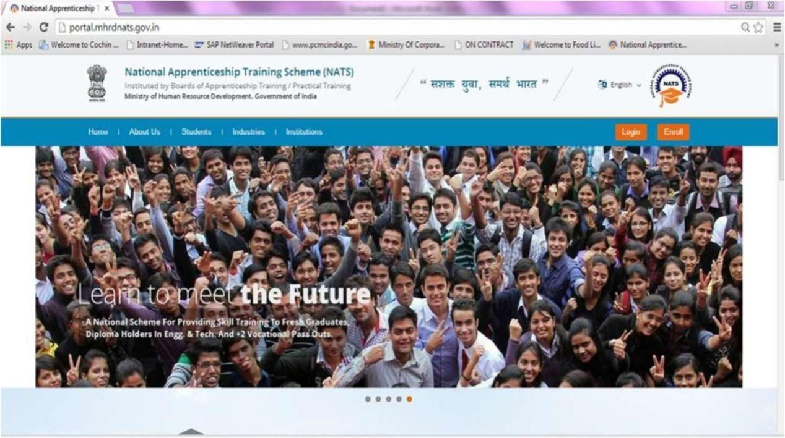

1. The page appears with **Eligibility** **Check** **(1)**, **Questionnaire** **&** **Guidelines** **(2)**, **EnrollmentForm** **(3)** and **Preview** **&** **Confirm** **(4)** sections as shown below:

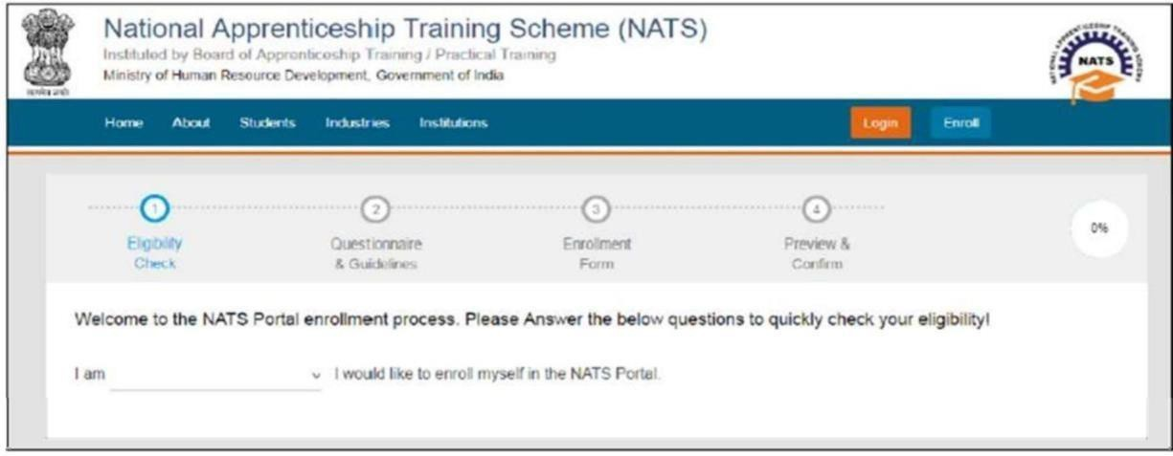

1. In the **Eligibility** **Check** **(1)** section, select “**Student”** from the drop-down list. Then other student related questions appear. Answer the questions related to eligibility check for the NATS programme.

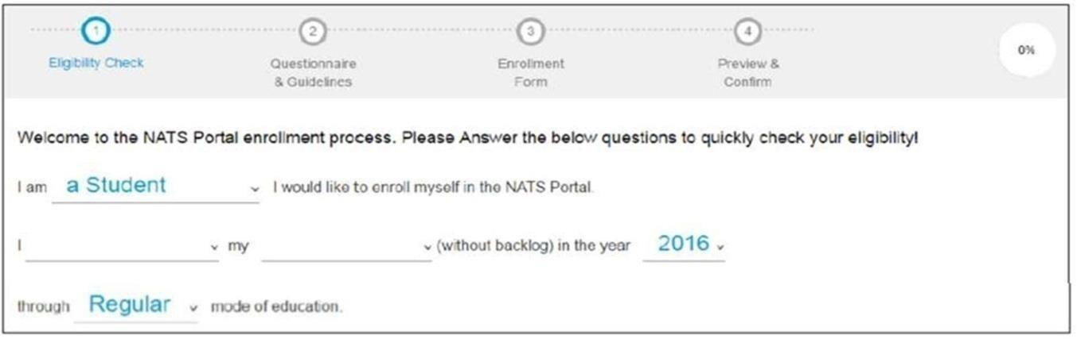

1. If you are eligible for the programme, the **‘Congrats! You** **are** **eligible** **to** **enroll’**

message appears.

1. If you are not eligible for the programme, the ‘**Sorry!** **You** **are** **not**

**eligible to enroll this apprentice Programme’** message appears.

1. **Ensure** **that** **you** **have** **the** **mandatory** **documents** and click ‘**I’ve above data’**. The **‘Let’s Get Started’** area is displayed.
2. In the **Primary** **Email** **ID** **box**, type your valid Email ID and click **Send** **OTP**. The One Time Password is sent to your Email Id.
3. In the **One** **Time** **Password** text box, type the password received on your

Email ID and then click “**Continue”**. The e-mail ID is now verified.

1. Then a **Mobile** **Number** **box** appears, enter your Mobile Number. The One Time Password is sent to your mobile number. Please enter the OTP in the box and click **“Continue”.** The mobile number is verified now.
2. Type your name in the **Name** **of** **the** **Student** field (as per certificate/marksheet) and type a password in the **Setup** **a** **Password** and **Confirm** **Password** fields.
3. In case you are unable to complete the process of enrollment, you can login by using the Email ID and password to complete the process of enrollment later.
4. To view the password as you type, click Show Password, and to hide the

password, click Hide Password.

1. Click “**Save** **and** **continue”**. The **Questionnaire** **&** **Guidelines** **(2)** section appears.
2. Read the guidelines, required enrollment documents and the terms and conditions and then select the **By** **clicking** **this** **box** **I** **agree** **to** **the** **above** **Terms** **and** **Conditions**

checkbox.

1. Click “**Agree and continue”** .The **Enrollment** **Form** section appears with Personal Information, Education Details and Training Preferences tabs.
2. On the Personal Information tab, type or select the required details.

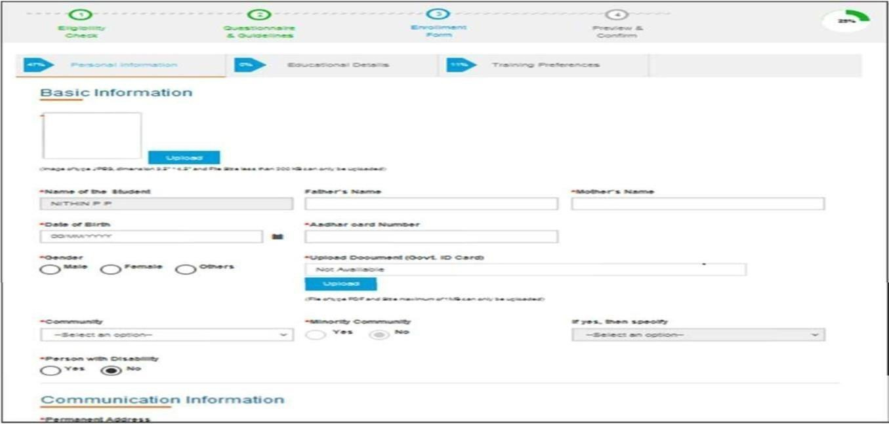

1. Click Save and continue. The Educational Details tab appears.

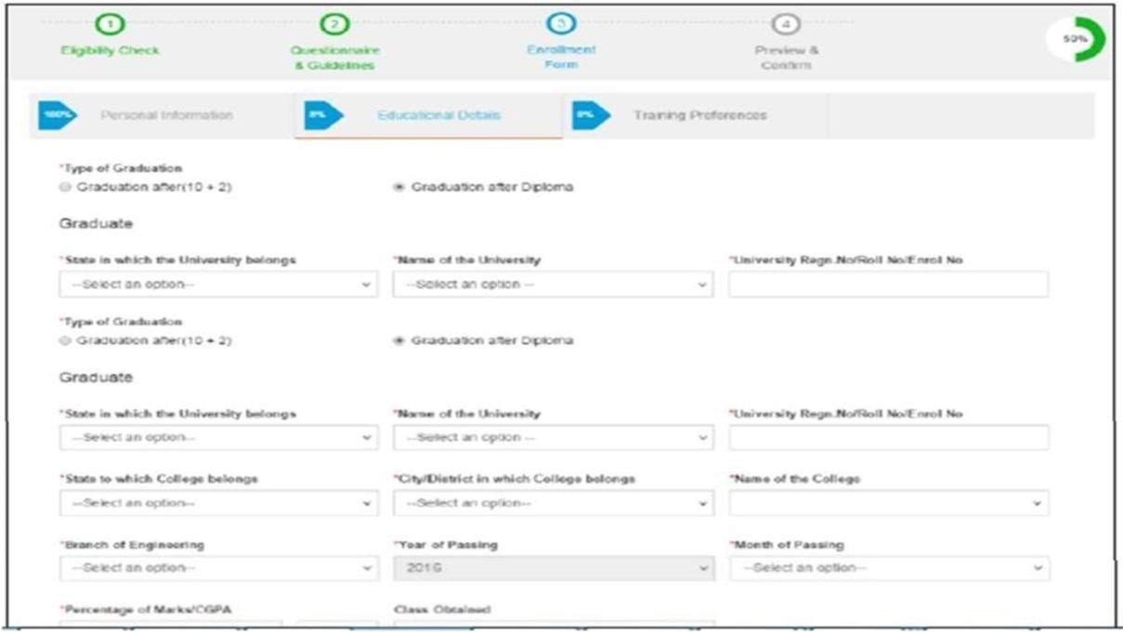

1. On the **Educational** **Details** tab, type or select the required details.

## Upload qualifying degree/ diploma/ provisional certificate.

1. Click **Save** **and** **continue**. The Training Preferences tab appears. On the

**Training** **Preferences** tab, type or select the required details.

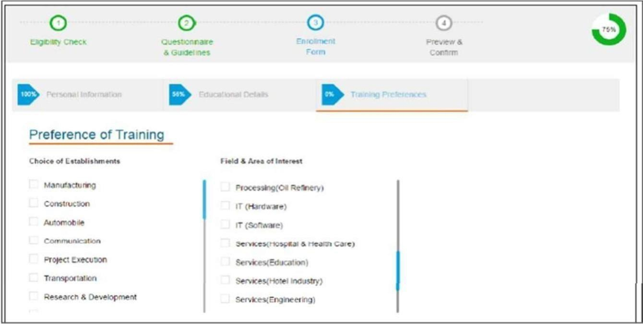

1. Read the Declaration given at the bottom of the page, and then select ‘**By** **clicking** **this**

**box** **I** **agree** **to** **the** **above** **Terms** **and** **Conditions’** check box.

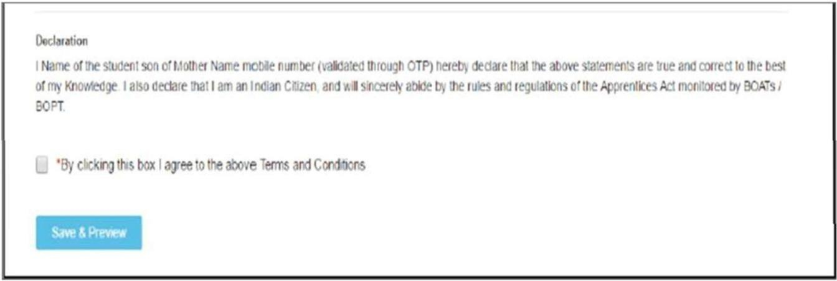

1. Click **Save** **and** **Preview**. The **Preview** **&** **Confirm** section appears.
2. Check all the entered details and click **Submit**. The enrollment is completed and the Enrollment Successful page appears with your **Email** **ID**, **User** **ID** and **Password** details.
3. To print the enrollment details, click **Print**.
4. Click **Close** **&** **Continue**. The Login page appears as given below. ***Candidates*** ***can*** ***log*** ***on*** ***the*** ***NATS*** ***Portal*** ***with*** ***the*** ***enrollment*** ***details*** ***shown*** ***in*** ***the*** ***printout.***

# ANNEXURE - II PROCEDURE TO APPLY FOR APPRENTICESHIP TRAINING IN AIRPORTS AUTHORITY OF INDIA

1. Logon to NATS Portal using your User ID/E-mail ID and password obtained after

enrollment.

1. In the home page **Click on “Establishment Requests” Tab** **And** **Select** **Option** **“Find Establishment”** from Drop Down Menu**.**

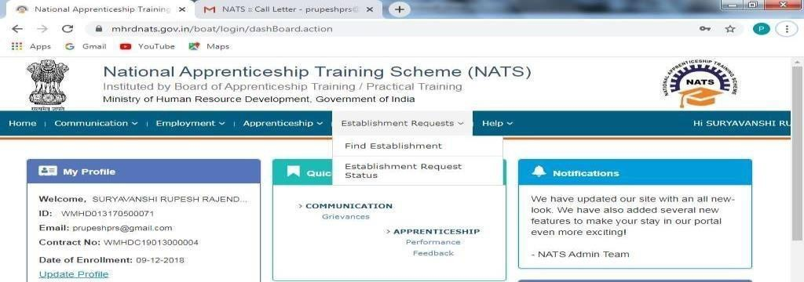

## Once you click on “Find Establishment”, below page appears with two “Search Criterions” i.e. Options to Search by 1) Preferences and 2) Establishment Name.

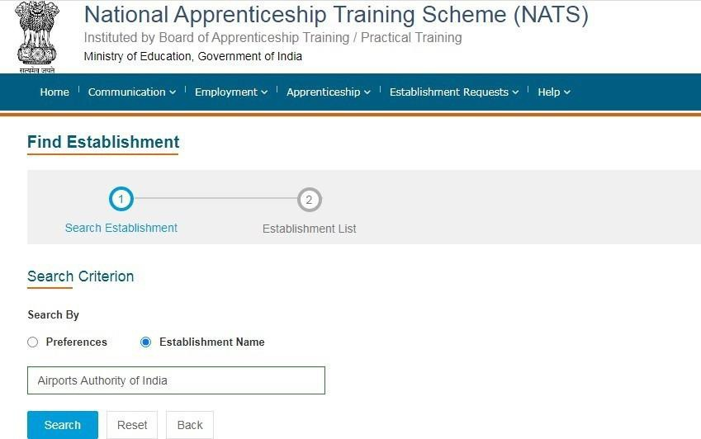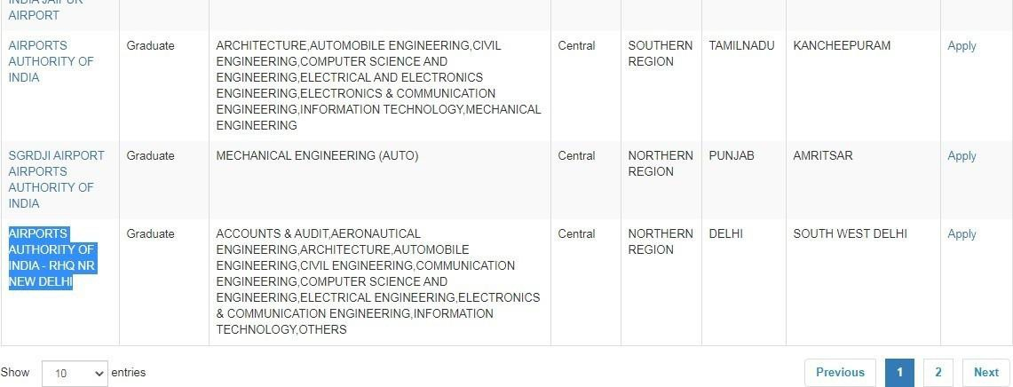

1. **Among** **the** **Search** **criterion** **options** **select** **Establishment** **Name,** **type** **AIRPORTS** **AUTHORITY** **OF** **INDIA** **and** **click on option “Search”.**
2. Once you click on “Search” below page appears listing current openings in AIRPORTS

AUTHORITY OF INDIA. **Click on Establishment name “AIRPORTS AUTHORITY OF INDIA”** (First column) & Region-**Eastern** **REGION** and Select **“Apply”** button given at the page.

1. Once you click on “Apply” button a message appears as given below **“Successfully applied for the training position. Based on availability, you will** **be** **contacted** **by** **the** **Establishment”.**

For detailed information, visit link shown below: https://nats.education.gov.in

**Annexure** **III**



